Software 2

Daily Meetings

**Team members:**

1. Kerolos Emad 42016045
2. Enas Alaa 42016017
3. Makarios Nassef 42016059
4. Manar Abdel Hamid 42016060
5. Mostafa Salah Eldin 42016057

TA/ Mona Mohammed

DR. Eid Abdel Hakim

**Requirements Specification**

**Functional Requirements:**

**1) Setup Meeting:**

1.1. Any user is allowed to initiate a request for a new meeting.

1.2. Once a request is added, the system automatically generates a suitable appointment for the group.

1.3. System shall be able to schedule a meeting, event or appointment with other calendar users.

1.4. Must provide a mechanism to include details accompanying the meeting.

1.5. Must provide option to set alerts/alarms/reminders (i.e., audio or visual notification).

1.6. Must provide a mechanism for better time planning and utilization.

**2) Meeting Notify:**

-2.1. Once the meeting is confirmed, the system shall be able to notify each user with the known date.

-2.2. The system is flexible, so it has the ability to send notification and receive request.

**3) User Response:**

-3.1. After sending a notification to users, it will receive a response from each user with the acceptance or rejection.

-3.2. The user has two choices either accept or decline.

-3.3. If the appointment date is convenient with the user, he shall be able to accept it.

-3.4. If the appointment date is inconvenient with the user, he shall be able to decline it.

**4) Check schedule:**

-4.1. Once user sends his response to the system, the schedule will work on it.

-4.2. The system will check his schedule to fill it with the chosen appointment.

**5) Rearrange:**

-5.1. In case of user rejection to the appointment date, the system shall be able to check his schedule.

-5.2. After that, change the current meeting with the chosen appointment, to prevent any kind of confliction.

-5.3. Give the changeable meeting a new date that doesn’t conflict with other appointment.

**6) Schedule Notify:**

-6.1. After replacing the appointment, the system shall be able to notify back the user with the updates.

-6.2.

**Nonfunctional requirements:**

**Security:** User request to access any data must be authorized first.

**Performance:** The elapsed time between the submission of a meeting request and the computation time to schedule a date should be minimal. Speed efficiency, resource usage, throughput, response time.

**Usability:** The system should be available, easy to use, and free from hardness and complexity. Also the system shall be usable by non-experts.

**Context model:**

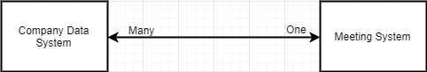

**Use cases:**

A close up of a map

Description generated with high confidence

**System:** Daily meeting

**Use case:** Setup Meeting

**Actor:** User,Daily-meeting system

**Data**: user initiate a request to the system, the system automatic generate appointment for the group. The system schedule a meeting.

**Stimulus:** allow user to initiate a request, generate appointment for the group.

**Response:** take user request and generate suitable appointment

**Comment:**

**Use case:** Meeting Notify

**Actor:** Daily-meeting system

**Data:** if the meeting is confirmed, the system shall be able to notify each user with the known date. The system is flexible, so it has the ability to send notification and receive request.

**Stimulus:** the system notifies each user with the known date, send notification and receive request.

**Response:** receive information and send schedule

**Comment:**

**Use case:** Response

**Actor:** Daily-meeting system, User

**Data:** sending a notification to users, it will receive a response from each user with the acceptance or rejection, the user has two choices either accept or decline.

If the appointment date is convenient with the user, he shall be able to accept it. If the appointment date is inconvenient with the user, he shall be able to decline it.

**Stimulus:** system sends a notification to users and receives a response from each user

**Response:** receive response and send notification

**Comment:**

**Use case:** Check schedule

**Actor:** User

**Data:** user sends his response to the system, the system identify that that appointment isn’t suitable and send for rearrange

**Stimulus:** receive the response of user as decline

**Response:** take response and identify problem

**Comment:** must take decline from user as respond

**Use case:** rearrange

**Actor:** Daily-meeting system, database

**Data:** If the user rejects the appointment date, the system will check his schedule then rearrange for the user another appointment for his activities and make the chosen appointment free for the meeting, to prevent any kind of confliction.

Give the changeable meeting a new date that doesn’t conflict with other appointment.

**Stimulus:** after user rejected the appointment date, the system will check his schedule and identify another meeting.

**Response:** take rejection and identifynew meeting

**Comment:**

**Use case:** Schedule Notify

**Actor:** Daily-meeting system, user

**Data:** After replacing the appointment, the system shall be able to notify back the user with the updates.

**Stimulus:** the system able to notify back the user with updates

**Response:** system announce user last update

**Comment:**

**Architectural pattern:**

Client-server architecture

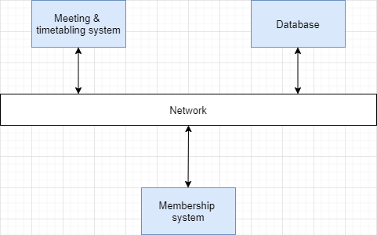

**Object-Class:**

We used tangible approach to identify our objects.

